## YOLOv7 Object Tracking using DeepSORT

DeepSORT is a Computer Vision Tracking Algorithm used to track the objects while assigning each of the tracked object a unique id. DeepSORT is an extension of the SORT. DeepSORT introduces deep learning into SORT algorithm by adding appearance descriptor to reduce the identity switches and hence making the tracking more efficient.

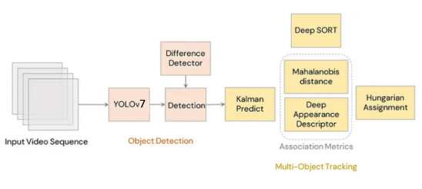

**Detection:**In the first step, detection of all the objects which are needed to be tracked in done using YOLOv4 or YOLOv7. The detections are then passed into the next step.

**Estimation*:*** For estimation, Kalman filters are used. Kalman filter is to use the available detections and previous predictions to arrive at a best guess of the current state, while keeping the possibility of errors in the process. To effectively track and predict the next state of the object, let us assume a constant velocity model. The detections are passed from the current frame to the next frame to estimate the position of the target in the next frame.

**Data Association*:*** Hungarian algorithm, is being effective and a simple data association problem.

**Creation and Deletion of Track Identities:**When object enters or leave the frame a unique object id’s are created and destroyed accordingly.

**Deep Appearance Descriptor**: Another distance metric rather than Mahalanobis distance is introduced based on the appearance of the object.

**D=Lambda∗Dk+(1−Lambda)∗Da**

 Dk is the Mahalanobis distance, Da is the cosine distance between the appearance feature vectors and Lambda is the weighting factor.